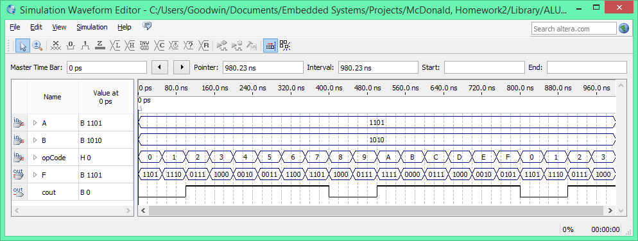

I did several test inputs and all the operations seemed to work. The only mistake I saw was that when I did 0000 for both A and B the carry out was set for the transfer operation. I believe the root of the issue goes back to my full adder and the logic used to find cOut. I do not believe the issue is a serious one however because after a program would run a transfer operation the cout flag would not be considered.